QUEENSLAND INDEPENDENT CAT COUNCIL (INC).
(Affiliated with A.C.F. Inc.)
Presents:

“May the Force be With You”
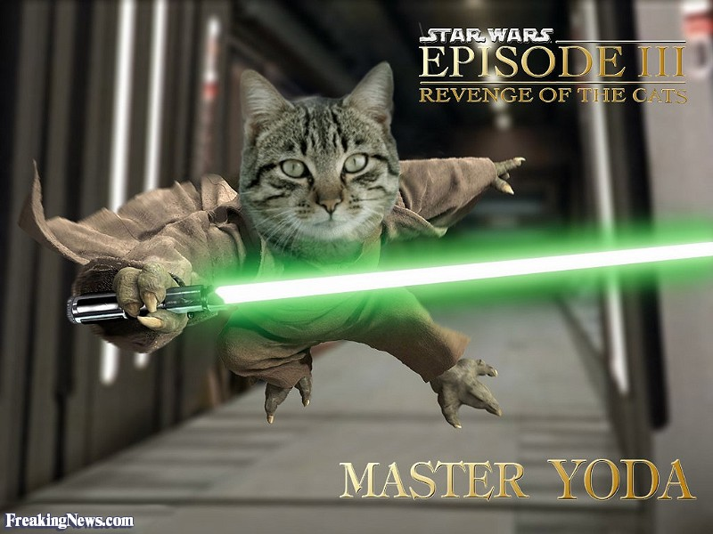

AUSTRALIAN STYLE 3 RING ALLBREEDS CAT SHOW, WITH AN ADDITIONAL FREE RING FOR GROUP 2!
Come Join Us for a Star Wars Themed Show!
Prizes for best decorated "Star Wars" cage and best dressed Exhibitor.
Sunday, 5th May 2019
Springwood Road State School, 94-120 Springwood Road, Springwood. Qld

Venue open at 7:30am. Judging starts at 9:00am
ENTRIES CLOSE: Monday, 29th April 2018
Please enter before closing date to avoid disappointment, late entries may be refused.

 | RING 1  Rosettes | RING 2  Breeder's Choice | RING 3  Taste of the Wild
ALL LONGHAIR  EXHIBITS | Barbara LaRocca  (QFA ACF) | Judy Lewis  (QFA ACF) | Marion Cooper  (FCCQ ACF)
ALL SHORTHAIR  EXHIBITS | Barbara LaRocca  (QFA ACF) | Judy Lewis  (QFA ACF) | Marion Cooper (FCCQ ACF)
COMPANIONS | Barbara LaRocca (QFA ACF) | Judy Lewis  (QFA ACF) | Marion Cooper (FCCQ ACF)

ADDITIONAL Speciality Group 2 Ring judged by Rodney McGregor (QICC Junior Judge),
TOP TEN PRIZES IN SHOW (Numbers Permitting) SPONSORED BY GLAMOURPUSS
Supreme Rosettes sponsored by Theresa Schermann
Supreme winners will win an Airline Crate, Black Cat Hosting Voucher, a Rosette and a Bag of Breeder’s Choice Litter. Also a $100 All Weather Cat Scratcher to be won in the Raffle sponsored by Aussieposhpaws.
The show committee reserves the right to alter judging assignments if necessary
Top ten prizes in all rings (numbers permitting)
WE WISH TO THANK OUR MAJOR SPONSORS

****CATERING BY NISMAT’S****

PLEASE MAKE CHEQUES OR MONEY ORDERS PAYABLE TO:

Queensland Independent Cat Council Inc.
EFT Payments to QICC Inc.
Bendigo Bank
BSB: 633-000
ACCOUNT: 158907634
Please state “name” and “May show”
Entries to: Sherin Henriksen, PO Box 9289 Wilsonton QLD 4350
Email: sherinhenriksen@hotmail.com

Note new show rule; kittens under the age of 12 WEEKS are not permitted to be shown, and that all kittens must have an accompanying F3 or equivalent vaccination certificate

ENTRY FEES: $30.00 per exhibit for 1st or ($12 per ring per exhibit)
$25.00 per exhibit for 2nd, 3rd
$20.00 per exhibit for 4th
$100.00 unlimited Exhibits (includes the Group 2 speciality ring)

LITTERS: $30.00 block entry – please see details on Litter entry section plus (optional) Litter Kittens to be judged individually : $2.00 each kitten

CATALOGUE: $ 6.00 Order & Pay with Entry Please

ADVERTISING: $10.00 Full Page $ 5.00 Half Page (completed copy to be supplied with entry)

STALLS: $20.00

EXHIBITION CAGES: For Exhibits not entered in the show: $10.00 SINGLE

QICC HIRE CAGES: $10.00 SINGLE

AWARDS: All Rings (numbers permitting) –Top 10 Kittens, Cats, Alters & Companions

CHALLENGES: All females, males, neuters & spays will compete in open classes by breed & colour

ACF AWARDS: (where merited) will be awarded in all rings to the best placed exhibit, Male, Female, Neuter, Spay in Groups 1, 2 & 3.

ACF companion Award of Honour - This award is open to any registered companion, over 9mths of age, who receives the best in show. The award will only be given where there is a min of 5 companions in the group. Exhibits must attain 15 certificates to be eligible for the award. There is to be one award per ring.

GDGC AWARDS: GDGC, Diamond, Argyle, Opal females, males, neuters and spays compete separately for the GDGC award in each Group.
10 GDGC Awards obtained at QICC shows only, are required to acquire QICC DIAMOND.
A further 15 GDGC awards are required for each elevation to QICC ARGYLE & QICC OPAL. (Companions not registered with QICC excepted).

HIGHER STATUS: Must be notified to the show manager SEVEN CLEAR DAYS prior to the show.

SUPREME EXHIBITS: Awarded on a Points Based System to highest scoring exhibit on the day.

THANK YOU TO OUR OTHER WONDERFUL SPONSORS
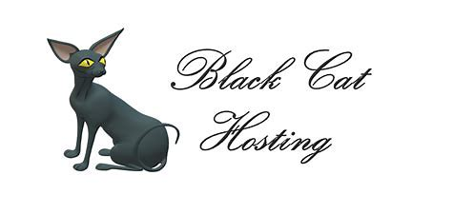

QICC INC SHOW ENTRY FORM

OWNER’s Declaration: I hereby declare that the particulars contained herein are true and correct to the best of my knowledge and enter my exhibit/s at my own risk. I declare that I am the bonafide owner/leasee and agree to abide by the rules of QICC Inc. I also agree to abide by any decision which may be made by the Veterinary Surgeon or, during the course of the day, the Show Committee regarding the health and/or show condition of my exhibit/s. My Exhibit/s have not been in contact with any contagious or infectious disease within 30 days prior to the show. This declaration applies to all exhibits, whether entered into the show or on exhibition only. I declare that any Kittens entered into this show have been vaccinated.

NAME: _______________________________SIGNATURE:______________________________________________________

ADDRESS:___ __________________________________________________________________________________________

DATE:____ ___________________________________PHONE: ______________________ EMAIL: _____________________

ENTRY FEES ______

CATALOGUE 6.00

ADVERTISING ______

EXHIBITION CAGE/S ______ (for those entries not entered into show)

DONATION ______

TOTAL ENCLOSED (cheque / money order)

ANY SPECIAL REQUESTS_______________________________________________________________

Any assistance offered at the show will be appreciated.

I would be willing to assist at the show as a ring clerk / steward / other (please circle)

___________________________________________________________________________________________________

LITTER ENTRY: must comprise all living progeny from one kittening of a Queen, of TWO or more kittens between the ages of 12 Weeks and 4 months and be exhibited by Breeder. Number and sex of kittens to be specified on Entry Form. Please fill out separate entry for each litter kitten to be entered into show.

PREFIX:_________________________________________________BREED: ___________________________________________

DATE OF BIRTH:_____________AGE on Day of Show: _________ NUMBER OF KITTENS:.Male ___________Female_____________

SIRE:__________________________________________________________________________________________________________ DAM:____________________________________________________________________________________________________________

BREEDER:.______________________________________

RING 1_________________ RING 2 _________________ RING 3 _________________ GROUP 2 RING_________________

IT IS NOT A REQUIREMENT TO SEND A PEDIGREE WITH YOUR ENTRY, HOWEVER, IT IS A REQUIREMENT THAT THE ENTRY FORMS ARE FILLED OUT IN FULL, WHETHER A PEDIGREE IS PROVIDED OR NOT.

PLEASE ENSURE THAT YOUR ENTRY FORMS ARE EITHER TYPED OR WRITTEN LEGIBILY

ENTRY SUMMARY SHEET – OWNER/S MUST COMPLETE DETAILS Please fill in cage details

OWNER’S NAME ……………………………………………………….CATALOGUE: YES / NO To Pay $......................
NAME OF EXHIBIT/S | KITTEN, CAT, ALTER, COMPANION  LONGHAIR SHORTHAIR | MARK IF BRINGING OWN APPROVED CAGE or  HIRE QICC - (S) SGL | QICC USE – CAGE NO.

QICC GENERAL SHOW SCHEDULE

This show schedule governs all Championship Cat Shows held by the Qld Independent Cat Council (QICC Inc) or its affiliated clubs. All shows are conducted under the rules of the QICC Inc and the show committee reserves the right to reject any entry without explanation.

1. All pedigree exhibits over the age of four months must be registered with a recognised body. All exhibits domiciled in Queensland must show a Queensland Registration Number.

2. Exhibits will be judged under the standard of points of the Aust Cat Federation Inc, together with other standards approved by the QICC Inc.

3. No exhibit, including those on exhibition only, suffering from any infectious or contagious disease will be allowed to enter upon or remain in the hall, neither shall any exhibit from a cattery that has been infected with Feline Enteritis within the preceding period of 3 months or any other infectious disease within the previous 30 days of show.

4. In Cage Vetting: A Vet may be present on the day to inspect all exhibits. He/she will be empowered to disqualify all exhibits which in their opinion are suffering from any infectious of contagious disease or are not in show condition. The Vet's decision is final. If any exhibit is rejected because of an infectious or contagious disease they may disqualify all the other exhibits from the same cattery at their discretion.

5. If a Vet is not present or has left the hall, then a Vetting-In committee comprising of three suitable QICC Inc members will be appointed to check exhibits on the day and request the removal of any exhibit they feel is not in show condition.

6. Cats obviously in kitten will not be judged. No kitten under the age of 12 weeks will be allowed within the precincts of the judging or benching areas. Queens obviously in milk shall not be benched without their litters.

6a. No kitten under the age of 12 weeks may be shown.

6b. All kittens being entered must have a current vaccination certificate for F3 at a minimum provided with their entry, or prior to the day, showing that the kitten has been vaccinated within 14 days prior to the show. No kitten will be permitted in the hall without this certificate having been provided.

7. ALL EXHIBITS MUST HAVE ALL THEIR CLAWS CLIPPED PRIOR TO THE SHOW.

8. A judge is empowered to withhold any award in any class if in his/her opinion the exhibit does not possess sufficient merit. Any protests can be made to the show committee, in writing, accompanied by a $20 fee within 7 days after the show. A judge may not judge an exhibit that has been domiciled at their home during the preceding 3 months, nor shall he/she compete in the same section of the show for which he/she has been appointed to judge.

9. An open challenge system is used. All entire/altered cats will compete in their own colours within their own breed. Challenges can be used in any status section. Gold Double Grand Champion Males/Females, Neuters/Speys will compete for one GDGC award within their own group.

10. All Companion Pets over the age of six months must be desexed.

11. NO EXHIBIT MAY BE REMOVED FROM THE HALL PRIOR TO THE CONCLUSION OF THE SHOW WITHOUT THE PERMISSION OF THE SHOW MANAGER OR MEMBER OF THE SHOW COMMITTEE.

12. DIFFICULT TO HANDLE CATS: If, at any time an exhibit shows itself to be difficult to handle or threatening, the Judge may call for the owner to remove the exhibit from it's cage and place it on the Judge's table. The Judge will then decide if she/he wishes to judge that animal. This procedure protects your cat from any unnecessary handling. Should your exhibit be marked "Unable to be Judged" then it is automatically withdrawn from any other rings and can not be shown again on the day. Should the judge consider the exhibit TO BE OF POOR TEMPERAMENT or in their opinion sufficiently difficult to handle, including excessively timid, the judge may withhold any awards at their discretion.

13. No exhibitor is to talk to a judge or heckle in the ring at any time during the course of the show about any exhibit that is not owned by them, without the owner’s permission. One warning will be issued and if any further offences occur the exhibitor and their exhibits will be asked to leave the show.

EXHIBITS NAME: ___________________________________________ REG No__________________

DATE OF BIRTH:_________________AGE on Show Date: _____yrs ______mths SEX: M F N S (circle)

SIRE: ____________________________________________________________________________________
DAM_____________________________________________________________________________________
BREEDER:_____________________________________OWNER:___________________________________
BREED:______________________________________COLOUR:___________________________________
RING 1________RING 2 _________RING 3_________ Speciality Ring _________

EXHIBITS NAME:_______________________________________________ REG No__________________

DATE OF BIRTH:_________________AGE on Show Date: _____yrs ______mths SEX: M F N S (circle)

SIRE: ____________________________________________________________________________________
DAM:____________________________________________________________________________________
BREEDER:_____________________________________OWNER:___________________________________
BREED:_______________________________________COLOUR:__________________________________
RING 1___________RING 2 ___________RING 3____________Speciality Ring_______________
__________________________________________________________________________________________

EXHIBITS NAME: ______________________________________________ REG No___________________

DATE OF BIRTH:_________________AGE on Show Date: _____yrs ______mths SEX: M F N S (circle)

SIRE: ____________________________________________________________________________________
DAM:____________________________________________________________________________________
BREEDER:__________________________________OWNER:___________________________________
BREED:____________________________________COLOUR:____________________________________
RING 1___________RING 2 __________RING 3_________ Speciality Ring_________
__________________________________________________________________________________________

EXHIBITS NAME:_____________________________________________ REG No:____________________

DATE OF BIRTH:_________________AGE on Show Date: _____yrs ______mths SEX: M F N S (circle)

SIRE: ____________________________________________________________________________________
DAM:___________________________________________________________________________________
BREEDER:__________________________________OWNER:___________________________________
BREED: ____________________________________COLOUR:_____________________________________
RING 1_________ RING 2 _________RING 3___________ Speciality Ring_________

